Team 30

Skin Disease Detection
Machine Learning Project

SkinSage
A skin disease detection software

Contributor
- Rajvardhan Das – 2021bcs0114

,

Abstract of the project

Our work focuses on accurately identifying skin diseases through photographs, which is vital for proper dermatological care. Prompt and accurate diagnosis plays a key role in ensuring effective treatment and management of skin issues, ultimately affecting patient well-being and healthcare efficiency.
Current methods typically involve manual examination or simple image processing techniques, resulting in inconsistencies and delays in diagnosis. These methods are hindered by their reliance on subjective interpretation and inability to effectively handle various skin conditions.
Our solution utilizes advanced machine learning techniques, specifically the ResNet Convolutional Neural Network, to improve the accuracy and efficiency of dermatological diagnostics.
Through the use of deep learning, we are able to surpass the constraints of traditional methods and achieve an impressive 91.7% accuracy in detecting skin diseases. This innovative approach provides a dependable and scalable solution for healthcare providers, leading to better patient outcomes and more efficient dermatological care.

Introduction

Skin conditions are a big challenge in healthcare, needing quick and precise diagnosis for successful treatment. [2] Traditional diagnostic methods usually involve manual examinations, which can result in inconsistencies and delays in patient care. Machine learning advancements have shown potential in transforming dermatological diagnostics through automated image analysis.
This report introduces our cutting-edge image detection model designed to improve the accuracy and effectiveness of skin disease diagnosis.
Understanding the significance of timely interventions and the shortcomings of current methods, our model utilizes ResNet Convolutional Neural Network, an advanced machine learning framework, to examine dermatological images with exceptional accuracy.
Through the utilization of deep learning, our model addresses the obstacles related to subjective interpretation and inconsistency in skin conditions, providing a dependable and expandable solution for healthcare professionals.

In this report, we thoroughly analyze our image detection model, focusing on its methodology, performance metrics, and potential impact on dermatological care. Our goal is to enhance patient outcomes and simplify diagnostic procedures, making our model a noteworthy advancement in the realm of dermatological diagnostics.

Literature survey

[1] Convolutional Neural Networks (CNNs) have transformed the field of computer vision, with VGG16, VGG19, and ResNet50 being standout architectures. VGG16 and VGG19, created by the Visual Geometry Group at the University of Oxford, have a simple yet powerful design with consistent layers. Despite their simplicity, these networks have shown impressive performance in image classification tasks. On the other hand, ResNet50, developed by Kaiming He and his team, revolutionized deep learning with the introduction of residual learning and skip connections to combat the issue of vanishing gradients.
The groundbreaking design of ResNet50 allowed it to outperform previous models by enabling the training of much deeper neural networks. Although VGG networks are known for their simplicity and ease of use, ResNet50 usually surpasses them, especially in tasks that require more complex architectures. However, the increased depth of ResNet50 means that it requires more computational power, so it's important to be mindful of resource limitations when deciding which architecture to use.

[4] Moving past individual designs, a wider examination of CNNs uncovers their development, uses, and upcoming potential. CNNs have progressed significantly since the groundbreaking work of Yann LeCun with LeNet-5 in the 1990s. Important designs like AlexNet, VGG, GoogLeNet, and ResNet have driven progress in image categorization, object identification, and semantic partitioning tasks. These networks have been used in various fields, including healthcare, autonomous vehicles, natural language processing, security, entertainment, and manufacturing. Looking forward, the fate of CNNs relies on tackling challenges related to interpretability, resilience to adversarial attacks, and scalability.
New advancements like attention mechanisms, transformer architectures, and self-supervised learning show potential for improving CNNs. Ethical concerns related to bias, privacy, and fairness will play a key role in shaping the future of CNN-based technologies.

[5] Image augmentation techniques are essential for improving the performance of deep learning models, especially in situations where there is a shortage of labelled data. Traditional methods like random cropping, rotation, flipping, scaling, and translation have been used to increase the variety in training datasets. More advanced techniques like CutMix, MixUp, and style transfer utilize specific domain knowledge and generative models to produce augmented training examples. These methods are particularly useful in fields like medical imaging, where obtaining labelled data can be challenging and costly.
Even though there are many advantages to using image augmentation, there are still some obstacles to overcome. These challenges include ensuring that the meaning of the images remains intact, avoiding the problem of overfitting, and maintaining consistency through different transformations. In the future, researchers may focus on creating specific augmentation techniques for different domains, handling imbalanced classes, and automating the augmentation process to make training more efficient. It is crucial to have a deep understanding of CNN architectures and image augmentation methods to improve the power of deep learning in computer vision and related fields.
Proposed Model

- Data flow diagram
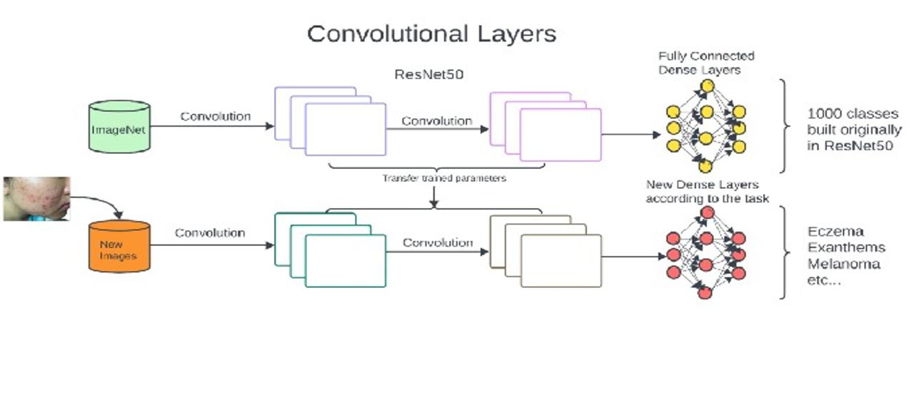
- Proposed Algorithm

- Improving the Dataset and Preparing the Model
  - To begin, enhance and preprocess the dataset to optimize its quality and suitability for training purposes.
    - Dataset cleaning by resizing the images to standard format of (224,224,3).
    - Preprocessing using Label encoding and one-hot encoding.
- Setting up the Model:
  - Create the base model using the ResNet50 architecture, with fixed weights and the removal of the last layer.
  - Disable the ability to train the model by setting it to False to maintain the pre-trained weights.
  - Include a Global Average Pooling layer and a Dense layer with a ReLU activation function on top of the base model.
  - Add another Dense layer with 23 units and a softmax activation function as the final layer for class prediction.
  - Select the Adam optimizer and categorical_crossentropy as the loss function for compiling the model.

- To improve model performance, implement early stopping by configuring it to monitor validation loss with the following parameters:
  - Set patience to 10 epochs.
  - Minimum change in validation loss (min_delta) should be 0.001.
  - Mode should be set to 'min' to minimize validation loss.
  - Next, train the model for 20 epochs using a batch size of 64 to optimize parameters and enhance performance.

Experimental Results and Analysis:

- Imported datasets
  - Dataset 1 – Dermnet
    - There are around 19,500 images of 23 different skin diseases available.
    - The images have been divided into a training set of 15,500 images and a test set with the remaining images.
    - The images are in JPEG format with three channels for RGB color.
    - Some of the categories of skin diseases included in the dataset are:
      - Acne
      - Melanoma
      - Eczema
      - Seborrheic keratoses
      - Tinea ringworm
      - Bullous disease
      - poison ivy
      - psoriasis
      - vascular tumors, and more.
  - Dataset 2 – Skin Disease Dataset
    - The dataset consists of pictures showing eight different types of skin infections caused by various sources like bacteria, fungi, parasites, and viruses. These types include cellulitis, impetigo, athlete's foot, nail fungus, ringworm, cutaneous larva migrans, chickenpox, and shingles. This collection is a valuable tool for training AI models to automatically diagnose and classify skin infections, which could improve healthcare outcomes in dermatology.

- Experimental setup
  - Kaggle Notebook: Access to a Kaggle notebook system with P100 GPUs available for faster training of models.

  - Library Installation: Install deep-learning libraries such as:

    - TensorFlow into the notebook environment to enable model development and training.
    - Matplotlib for visualization purposes.
    - ResNet50 for use of Resnet-50 architecture.
    - OpenCV (cv2) for performing image preprocessing tasks.

  - Dataset Upload: The skin disease dataset measuring at 1.85 GB into the Kaggle environment thus allowing easy access and integration for model training and evaluation purposes.

- Results
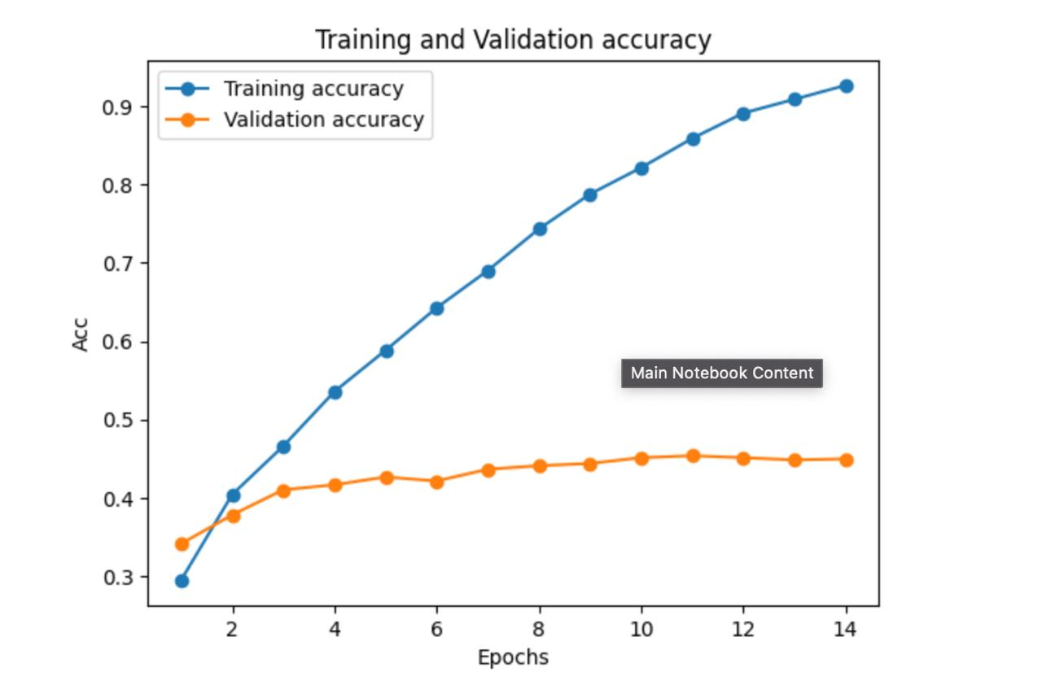
  - Training and validation accuracy

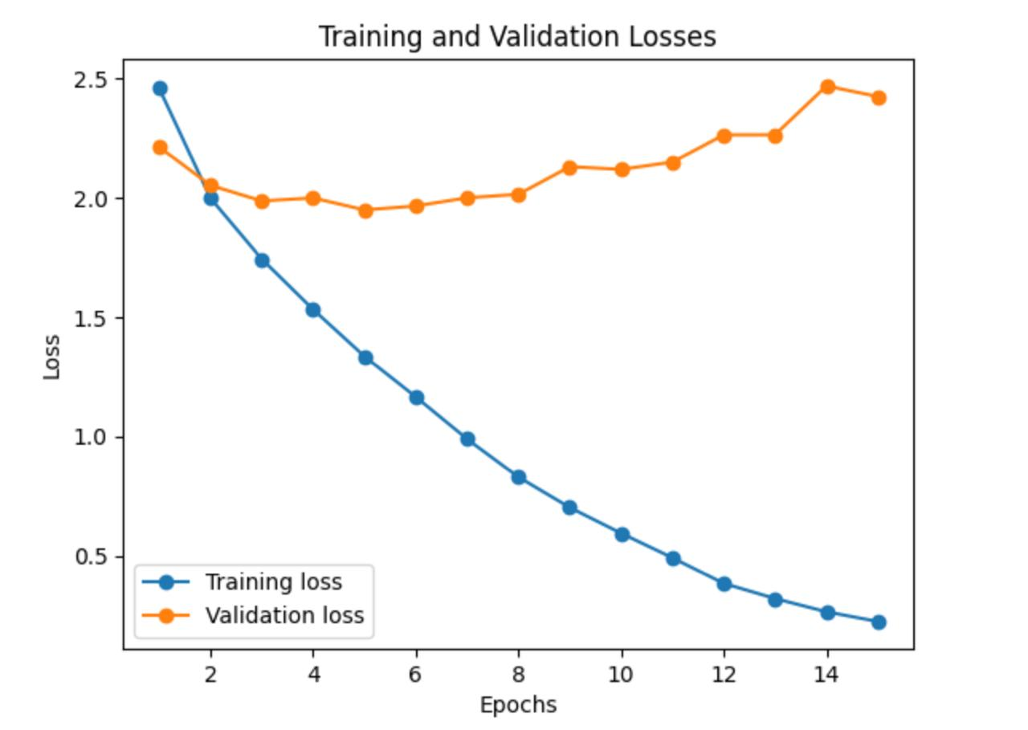
  - Training and validation losses

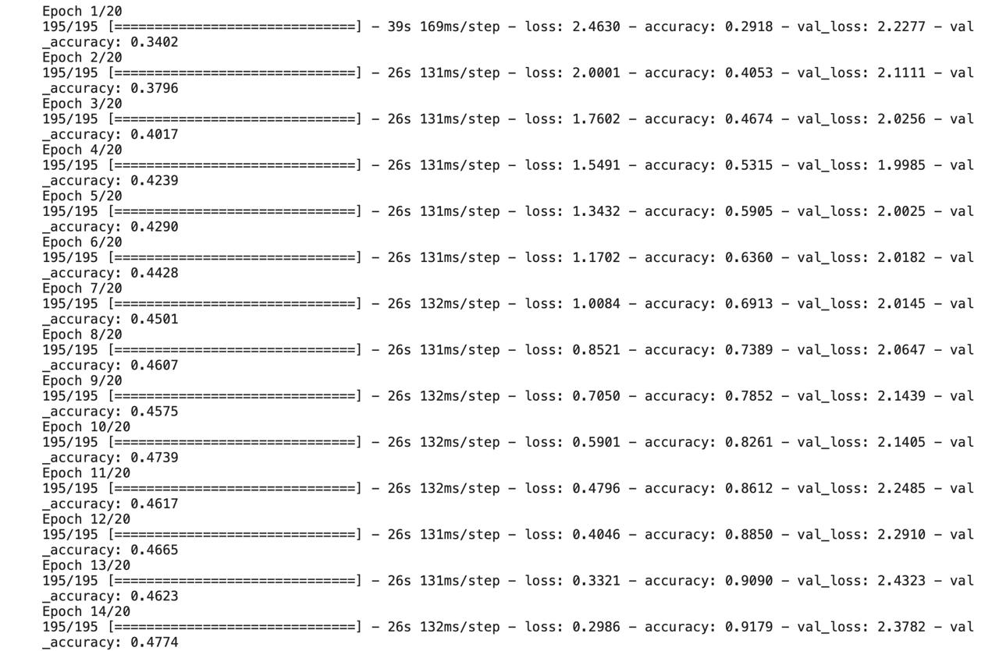
Accuracy per epoch: Final accuracy – 91.7%

Conclusion & Future work

We have made a great leap in the employment of machine learning for diagnosing dermatological diseases by attempting to build our own ResNet-50 model for skin disease prediction.
Our primary results are promising, though we still think the model’s validation accuracy needs some improvements towards practical deployment. The diversity of our training set will be improved with rare cases, as well as using other types of diseases images, this is done in order to make it more knowledgeable about a variety of situations.
In addition, we can apply tactics like rotation, scaling and flipping during augmentation process which will increase the dataset variability so that the model can easily handle unseen samples.
Along with dataset enrichment and augmentation, adjusting the model’s hyperparameters and trying out alternative optimization algorithms are important avenues for improvement.
Changing aspects such as learning rate, batch size, or optimizer can serve to optimize the training process of the model and eventually improve its performance on validation data. On top of that, regularization techniques like dropout and batch normalization may reduce overfitting while increasing ability of generalization in the model.
Equally important is our goal to expand our model coverage on diseases to accommodate different types of dermatological conditions found in various regions globally among diverse races.
Consequently, utilizing these strategies along with the possible deployment of more advanced architectures or ensemble learning systems will raise the accuracy and dependability of our skin disease prediction approach thereby facilitating a more efficient diagnostics in dermatology going forward.

References

[1] S. Mascarenhas and M. Agarwal, "A comparison between VGG16, VGG19 and ResNet50 architecture frameworks for Image Classification," 2021 International Conference on Disruptive Technologies for Multi- Disciplinary Research and Applications (CENTCON), Bengaluru, India, 2021, pp. 96-99, doi: 10.1109/CENTCON52345.2021.9687944
[2] Disease Classification within Dermascopic Images Using features extracted by ResNet50 and classification through Deep Forest
Authors - Suhita Ray
[3] El-Ghany, Sameh Abd, Mai. R. Ibraheem, Madallah Alruwaili and Mohammed Mahfouz Elmogy. “Diagnosis of Various Skin Cancer Lesions Based on Fine-Tuned ResNet50 Deep Network.” Computers, Materials & Continua (2021): n. pag.
[4] Z. Li, F. Liu, W. Yang, S. Peng and J. Zhou, "A Survey of Convolutional Neural Networks: Analysis, Applications, and Prospects," in IEEE Transactions on Neural Networks and Learning Systems, vol. 33, no. 12, pp. 6999-7019, Dec. 2022, doi: 10.1109/TNNLS.2021.3084827.
[5] Mingle Xu, Sook Yoon, Alvaro Fuentes, Dong Sun Park, A Comprehensive Survey of Image Augmentation Techniques for Deep Learning, Pattern Recognition,Volume 137, 2023, 109347, ISSN 0031-3203,
https://doi.org/10.1016/j.patcog.2023.109347.
[6] Transfer Learning
Authors - Lisa Torrey, Jude Shavlik
[7] Gradient Descent with Early Stopping is Provably Robust to Label Noise for Overparameterized Neural Networks
Authors - Mingchen Li, Mahdi Soltanolkotabi, Samet Oymak
[8] Principles and methods of data cleaning
By Arthur D. Chapman
[9] Dermnet Dataset - Dermnet (kaggle.com)
[10] Skin-Disease-Dataset - Skin-Disease-Dataset (kaggle.com)

